PATUAKHALI SCIENCE AND TECHNOLOGY UNIVERSITY

**Assignment Name: Lab Problem 06**

**Course Code: CCE-314**

**Course Title: Computer Networks Sessional**

Submitted by:

**Arfan Ahmed**

ID No.: 2002040

Registration No.: 09557

Level-3, Semester-1, Session: 2020-2021

Faculty of Computer Science & Engineering

Submitted to:

**Dr. Md. Samsuzzaman**

Professor

Department of Computer and Communication Engineering

Faculty of Computer Science and Engineering

Date of Submission: June 15, 2024

* + 1. : Skills Integration Challenge-Routing IP Packets

**Topology Diagram**

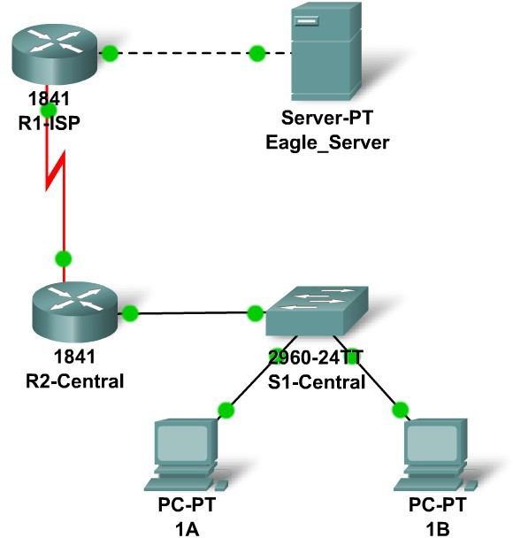

**Addressing Table**

|  |  |  |  |  |
| --- | --- | --- | --- | --- |
| **Device** | **Interface** | **IP Address** | **Subnet Mask** | **Default Gateway** |
| **R1-ISP** | **Fa0/0** | **192.168.254.253** | **255.255.255.0** | **N/A** |
| **S0/0/0** | **10.10.10.6** | **255.255.255.252** | **N/A** |
| **R2-**  **Central** | **Fa0/0** | **172.16.255.254** | **255.255.0.0** | **N/A** |
| **S0/0/0** | **10.10.10.5** | **255.255.255.252** | **N/A** |
| **S1-**  **Central** | **VLAN 1** | **172.16.254.1** | **255.255.0.0** | **172.16.255.254** |
| **PC 1A** | **NIC** | **172.16.1.1** | **255.255.0.0** | **172.16.255.254** |
| **PC 1B** | **NIC** | **172.16.1.2** | **255.255.0.0** | **172.16.255.254** |
| **Eagle Server** | **NIC** | **192.168.254.254** | **255.255.255.0** | **192.168.254.253** |

**Learning Objectives**

* + - * Configure a router interface using a GUI
      * Explore a routing table
      * Configure a static route using a GUI
      * Explore the routing of IP packets

**Background**

Throughout the course you will be using a standard lab setup created from actual PCs, servers, routers, and switches to learn networking concepts. At the end of each chapter, you will build increasingly larger parts of this topology in Packet Tracer, and analyze increasingly more complex protocol interactions. You have already studied a variety of application protocols, such as DNS, HTTP, TFTP, DHCP, and Telnet, and two transport layer protocols, TCP and UDP. You may have noticed that regardless of what application and transport protocols were involved, in **Inbound** and **Outbound PDU Details** view they were always encapsulated in IP Packets. In this activity we will examine how the Internet Protocol, the dominant network layer protocol of the Internet, works in the context of a simple example of IP routing.

# Task 1: Configure a Router Interface.

There are problems on the local area network: PC 1A cannot reach the Eagle Server (verify this in Realtime mode). It appears there is a problem with the router. Mouse over the R2-Central router, and note the condition of the Fa0/0 interface (to which switch is connected. This interface must have an IP address, subnet mask, and be turned on in order to act as the default gateway for the LAN. Click on router R2-Central, and go to the **Config** tab. At the end of the course, you will learn how to use the Cisco Internetwork Operating System (IOS) command line interface (CLI) to perform this task. For now, the **Config** tab is easier and will allow you to focus on the basic idea of IP routing. In the list shown, find **INTERFACE, FastEthernet0/0**. Add the IP address 172.16.255.254 with subnet mask of 255.255.0.0, and turn the port on. Close the router window. Verify that the router interface (port) is now working by using the mouse over. Try reaching Eagle Server. The request still fails. What are some possible reasons why?

# Task 2: Examining Routes.

Use the **Inspect Tool** (magnifying glass) to examine the routing table of R2-Central. You will see the router's directly connected networks, but there is no way to reach the Eagle Server network.

# Task 3: Configure a Route Using a GUI.

Click on router R2-Central and go to the **Config** tab. In the list shown find **ROUTING, Static**. Configure what is known as a default static route, using the address 0.0.0.0, mask 0.0.0.0, and the next hop of 10.10.10.6 (the S0/0/0 interface on the R1-ISP router) and click the **Add** button. This route is configured so that wherever packets from the 172.16.0.0 /16 LAN are destined, they will go to the R1-ISP router. Under **GLOBAL, Settings**, click on the **Save** button to save the interface and route configuration you have just done to NVRAM in case the router is power cycled. Use the **Inspect Tool** (magnifying glass) to examine the routing table of R2-Central again. You should now see the route you configured in the routing table.

Verify your work using feedback from the **Check Results** button and the **Assessment Items** tab. Test connectivity, in Realtime, by using ADD SIMPLE PDU to test connectivity between PC 1A and the Eagle Server. The PDU, a one-shot ping, will appear in the User Created PDU List for future use as well. The first ping attempt will fail because the ARP tables are not populated; double click on **Fire** to send it again - this should be successful.

# Task 4: Examine the Routing of the IP Packet.

Switch to Simulation mode. Using the PDU you created in Task 3, trace the packet's journey from PC 1A to Eagle Server and back using the **Capture / Forward** button and examining the packet's contents by either clicking on the envelope or clicking on the colored square in the **Info** column of the **Event List**.

**Reflection**

What data can an IP Packet contain? What is meant by the phrase "the IP packet is routed"? What is a route? Where might things go wrong?